Koinex –

Login Update KYC Load Money Buy Sell Withdraw Order History

Attaching

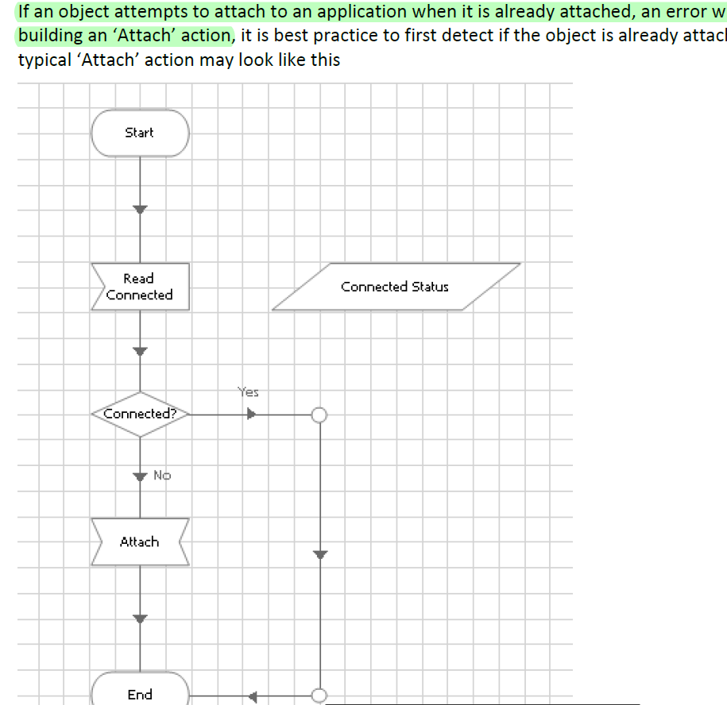

**Read Stage**

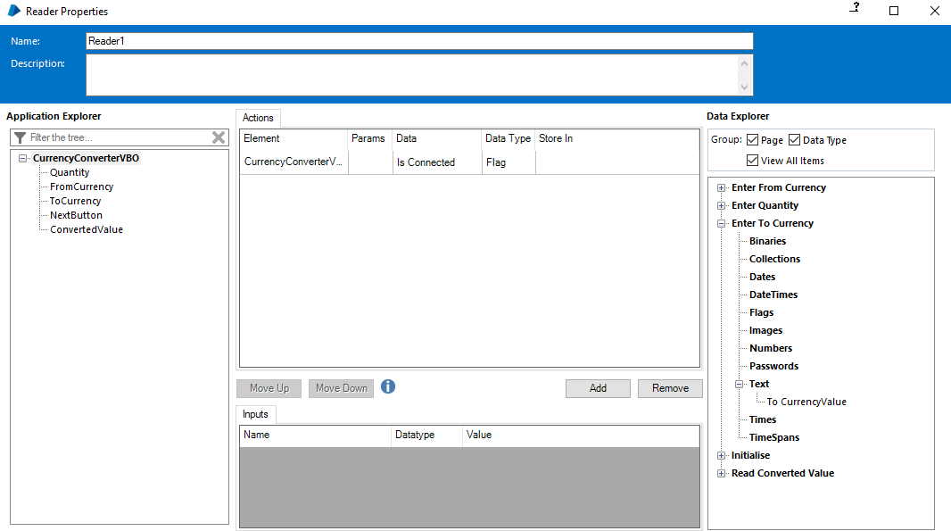

**Navigate Stage**

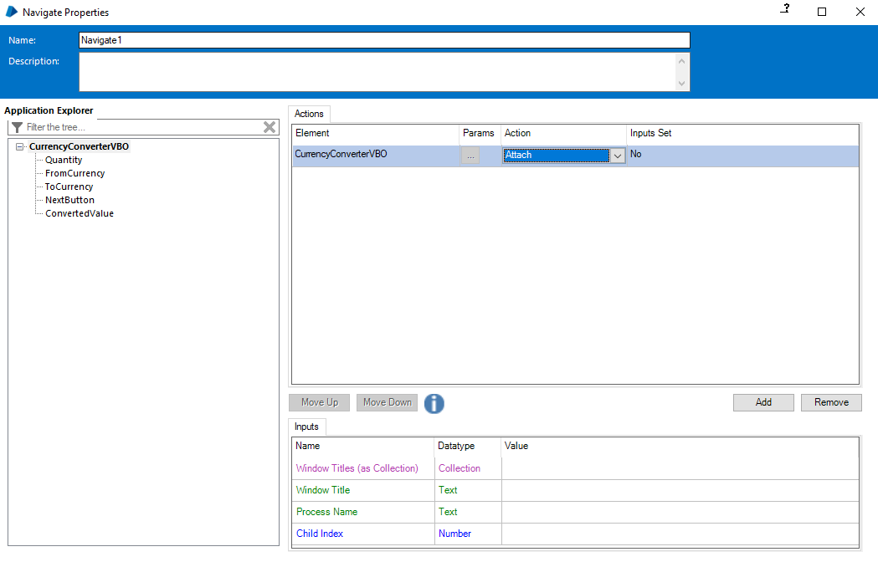

Can we put this in begin stage ?